

Document Title: | Processing of Credit Note and Manual PO
Document Number: | SCD-PSP-PRT-WI-017
Revision Number: | 00
Prepared by: | Rashel Nacor – Manager, OS&E, Procurement and Strategic Planning
Reviewed by: | Revelina Basada – Manager, Quality Management System and Strategic Planning/Execution
Approved by : | Jeric Conway Miranda – Senior Manager, OS&E, Procurement and Strategic Planning
Effectivity Date: | July 26, 2021

- REFERENCE SOP or GUIDELINE: Source to Procure (SCD-PSP-PRT-OP-001)

- RESPONSIBILITY / PROCEDURE DETAILS
  - Procurement Buyer
    - Log in to Redrock.

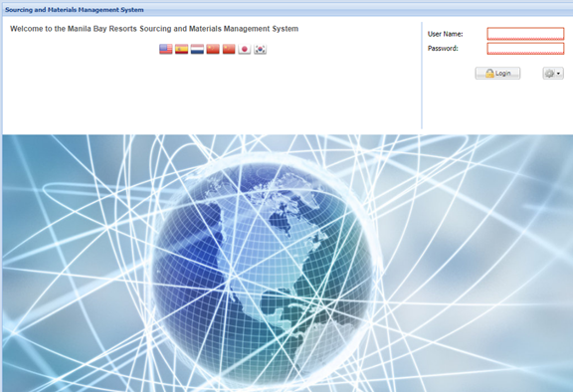

    - Go to Procurement > Orders > Create an Order

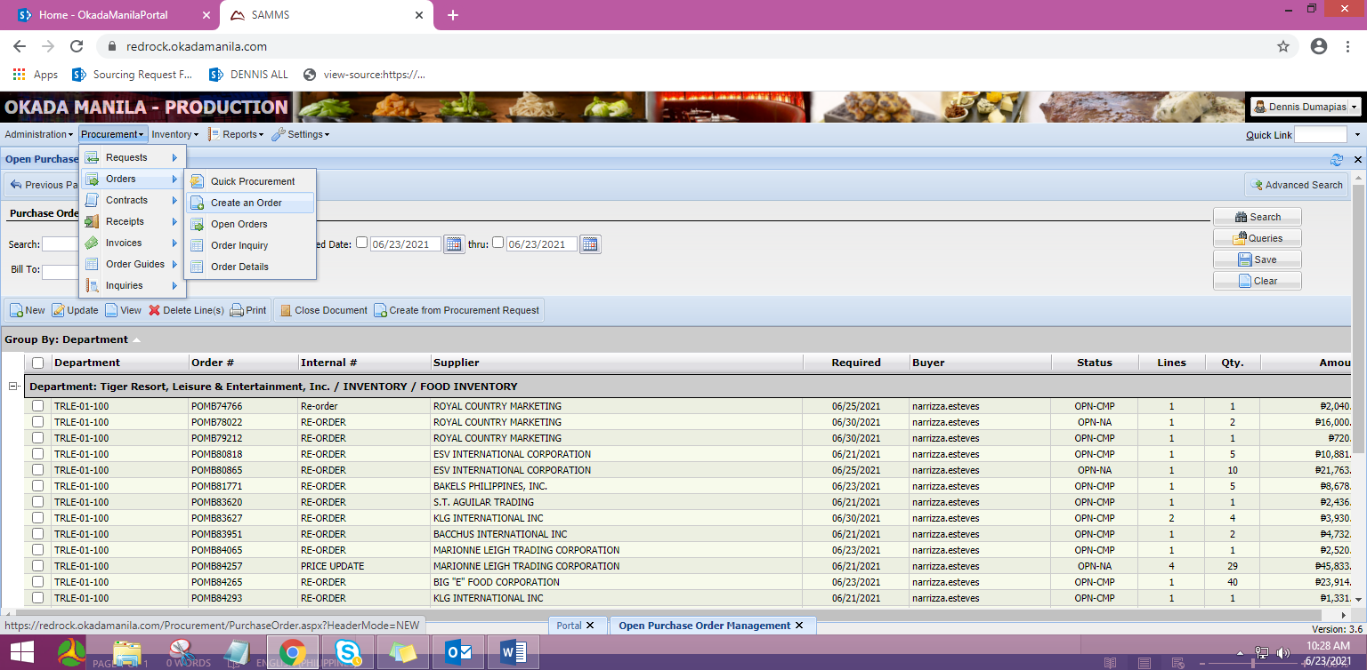

2.1.3 Update the critical PO header details:
2.1.3.1 BILL TO DEPARTMENT = Cost Center where the purchase will be charged.
      - REQUIRED DATE = Agreed delivery date based on Incoterms
      - CURRENCY (Note: Base Currency = Philippine Peso, Php)
      - RECEIVING AREA (Note: Maintain default code RECV)
      - INTERNAL REFERENCE = specify how PO is created, use Credit Note

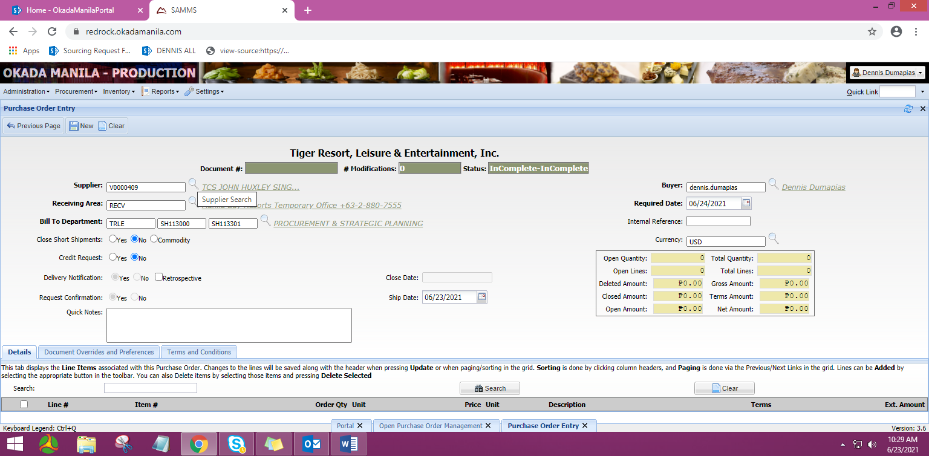

2.1.3.6 Click ‘New’ button to generate a PO number

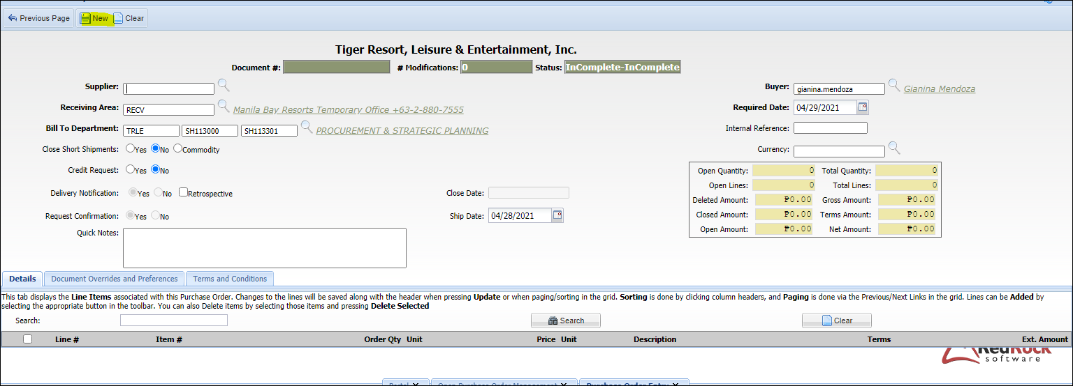

    - Adding the item level in the PO.
2.1.4.1 Click ‘Items’ button to add an sku indicated in the credit memo.

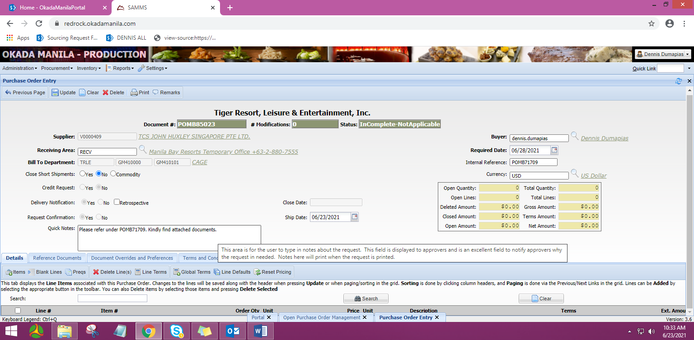

2.1.4.2 Search the Credit Note or the item needed for Manual PO in the item description.
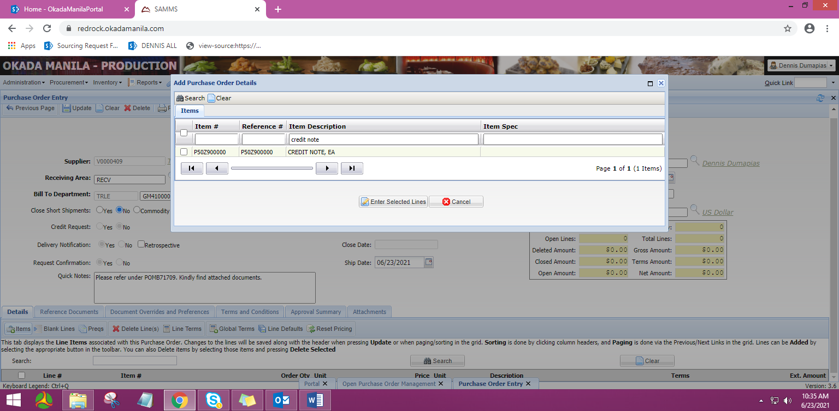

2.1.4.3 Tick the box of desired item code.



2.1.4.4 Click ‘Enter Selected Lines’ button.



      - For Credit Note PO, manually enter the negative quantity and amount under Price Field. The amount should be in negative value based on the agreed Credit Memo.

Note: A CREDIT MEMO or Agreement is required prior issuance of the Credit Note PO as confirmed by Procurement Section Leads.

      - For Manual PO, price will automatically appear for the selected SKU based on the updated price in the system.

Note: A SPECIAL APPROVAL from the VP SCD is needed prior issuance, based on urgency or need to release a PO without a corresponding PR, thru the endorsement of the issuing Procurement Section Leads.

      - Click “Create Selected Line Items”

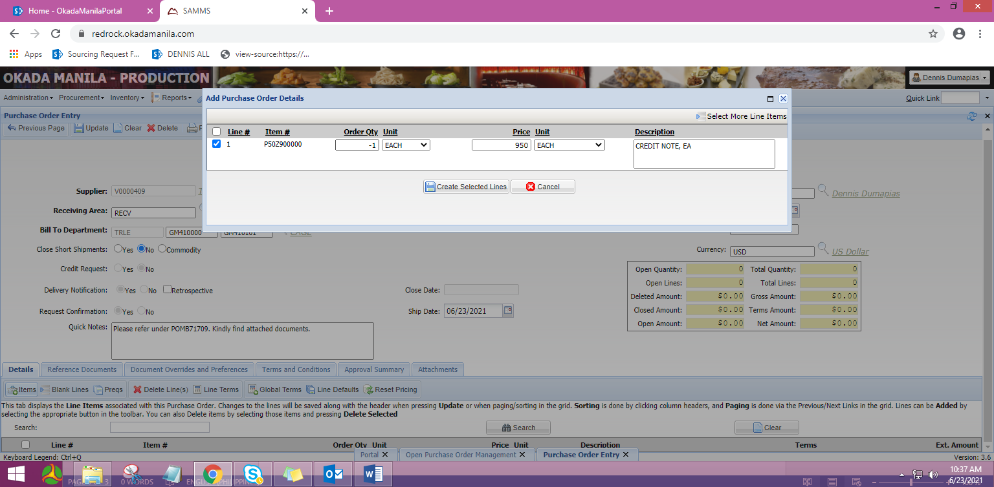

    - You may add notes to the following modules:

      - Add Quick Notes (for Okada Manila personnel & suppliers)



      - Add Remarks:
2.1.5.6.1 Internal (for Okada Manila personnel & suppliers)
2.1.5.6.2 External (can be viewed by Suppliers)

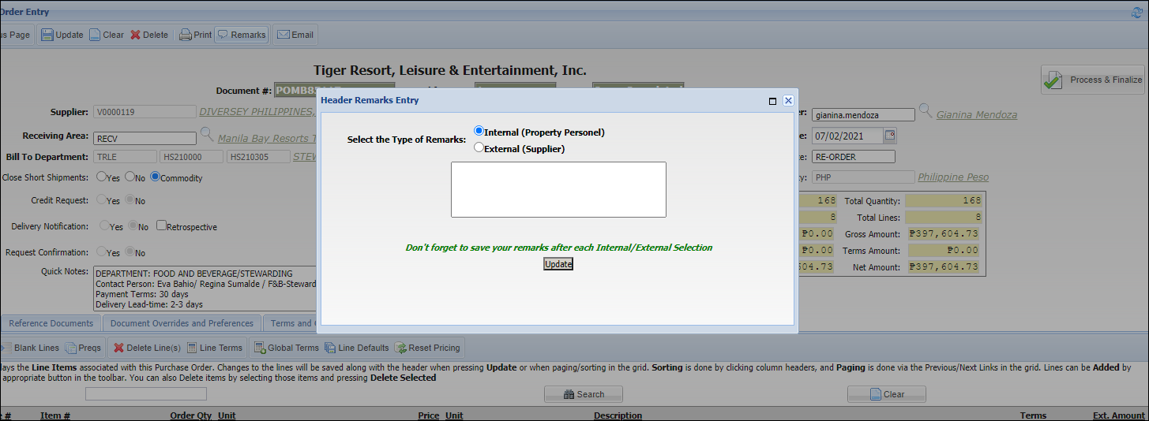

      - If notes are added under Internal/External Remarks, click ‘Update’ button to save it.



    - Click ‘Attachments’ tab to attach any supporting documents to the PO (bid tabulation, Ringi, e-mail, credit note from the supplier, etc).

    - To attach file from your computer, click ‘Choose File’ button and select the document/s needed, especially the Credit Memo / Agreement or the special approval to issue the Manual PO.
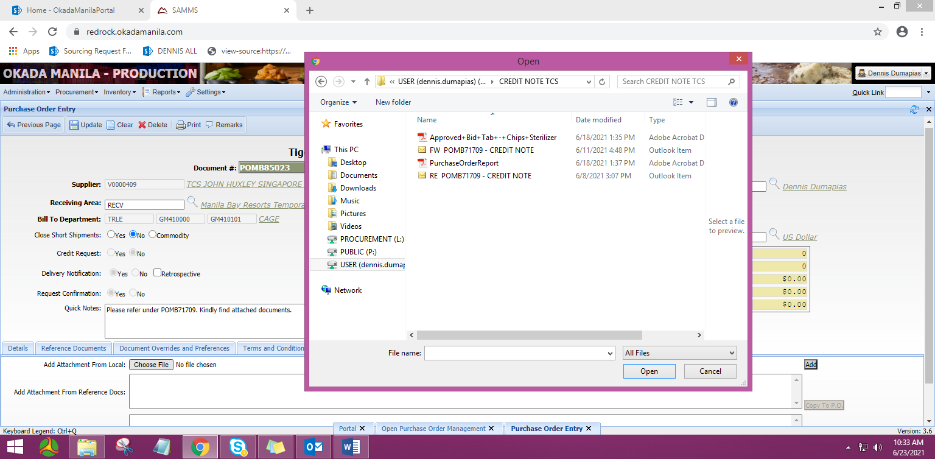

    - After choosing a document, click ‘Add’ button.

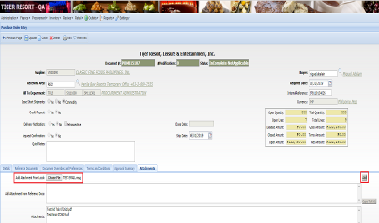

Attachment/s has been added:

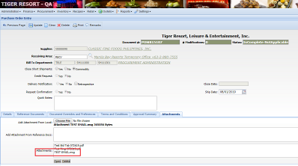

    - If PO details are all complete & correct, click ‘Update’ button to save it.

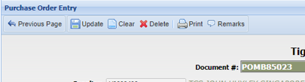

    - Click ‘Process & Finalize’ button for the PO to route for approval.

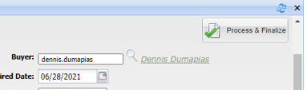

    - Tick the ‘Email’ button.

    - Click the magnifying glass button to add the person/s who need/s to receive the PO notification.

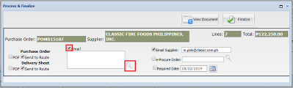

    - Tick the name/s of the person/s.

    - Click ‘Select Checked’ button.

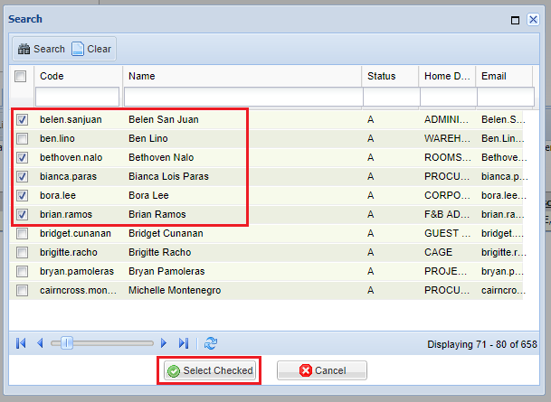

    - Click ‘Finalize’ button for the PO to be routed for approval.

Note:
1. Make sure that ‘Email Supplier’ is ticked.
2. DO NOT add supplier’s email address/es manually to below module. Make sure to notify SRM if there any changes to their contact details.

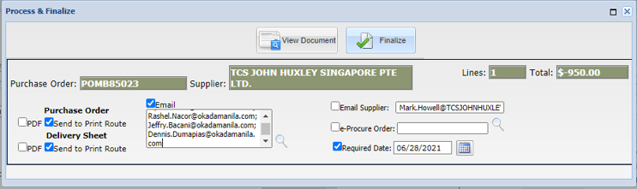

    - Go back to Redrock homepage to check the PO. It will appear on ‘My Recent Purchase Documents’.

Status is: INC-WTG meaning waiting for approval
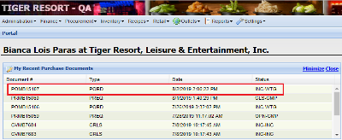

If PO has been approved, status will change from INC-WTG to OPN-CMP.
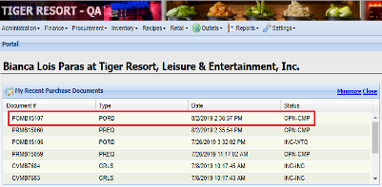

    - To view the printed version of the PO, Double-click the PO.
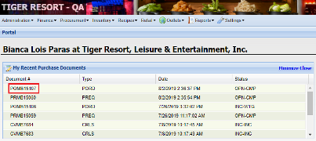

    - Click ‘Print’ button.



    - Once PO has been approved, notification email will be send directly to the supplier.

PO Preview:
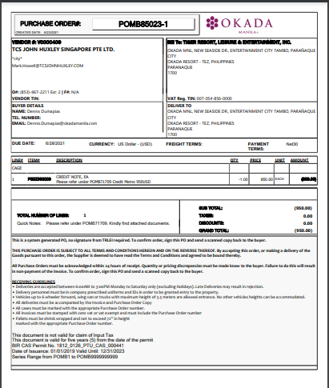

- FORMS
None

- REVISION HISTORY:
Revision No. | Effective Date | Reason of Revision | Prepared by | Reviewed by | Approved by
00 | July 26,2021 | Initial | R.Nacor | R.O.Basada | JC Miranda
Prepared by:  __________________________  Rashel Nacor  Manager, OS&E,  Procurement and Strategic Planning | Reviewed by:  _________________________  Revelina O. Basada  Manager, QMS and Strategic  Planning / Execution | Approved by:  _________________________  Jeric Conway Miranda  Senior Manager, OS&E, Procurement and Strategic Planning

